http://abelsiqueira.github.io/blog/introduction-to-performance-profile/:

Introduction to Performance Profile
May 09, 2017
Contents
Introduction to Performance Profile 1
Performance Profile 2
Example 4
Implementations 5
References 6

The comparison of algorithms is an active area of work. When we start learning algorithms, or more advanced programming, we learn of different ways of doing the same complex task. The most usual first example is sorting, which introduces a series of different ways to sort a single array, such as selection sort, insertion sort, quick sort, merge sort, etc. When comparing these algorithms, we take into account a few things: how fast it is, how much memory it needs, what are the best/worst/average-case complexities, and so on.
However, in some areas, specially applied mathematics, we have an added complication: does the algorithm work? (Or does it work with a given budget?) That happens because some types of problems don’t have an algorithm that can solve every problem. In particular, consider the problem of finding the minimum value of a function on a set . There are no algorithms that solve this problem for any given and , and even for specific, easier, cases, such as when is twice-continuously differentiable and =, it could happen that the algorithm steps would take more time than allowed (or some other budget constraint). In these cases, we need another type of comparison between algorithms that take into account the number of problems that are solved.

Performance Profile
Develop by Dolan and Moré [1], the performance profile takes into account the number of problems solved as well as the cost it took to solve it. It scaled the cost of solving the problem according to the best solver for that problem. Given a set of problems and a set of algorithms , we define as the cost of solving problem by algorithm . If algorithm can’t solve the problem , we define . We assume that at least one algorithm solves problem . The best algorithm for a given problem is the one that solves it with the least cost, i.e., we define
Now we define the relative cost of the algorithm on a problem:
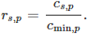
Notice that , with meaning that algorithm is (one of) the best for problem . Finally, the performance function of algorithm is given by
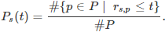
See that is the number of problems such that , that is the number of problems for which algorithm is one of the best. Furthermore, is the number of problems solved by algorithm , where
The value is called the efficiency of algorithm and is the robustness.
The following image shows an example of performance profile:
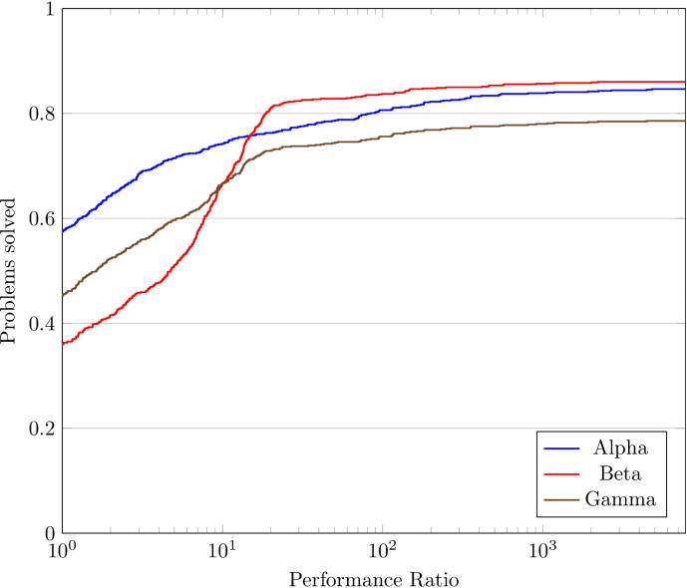

Example
I’m gonna create a simple example. Suppose there are 30 problems and 3 solvers and the the following matrix stores the values of :
c = rand(30, 3)
c[rand(1:90, 10)] = Inf # To simulate failure
The following code computes the minimum, the ratios and the performance function plots:
cmin = minimum(c, 2)
R = c ./ cmin
t = sort(unique(R))
if t[end] == Inf
pop!(t)
end
plot(xaxis=:log)
for i = 1:size(c, 2)
plot!(t, [sum(R[:,i] .<= ti)/size(c,1) for ti in t], label="Alg $i", t=:steppre, lw=2)
end
ylims!(0, 1)

The resulting image is
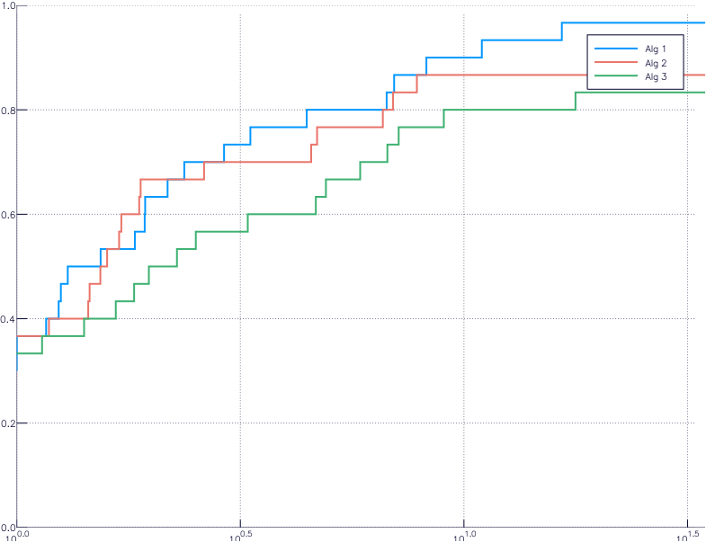

Implementations
The traditional implementation of the performance profile was in MatLab, but I can’t find it now. Let me know if you have a link to it, so I’ll add here.
Another implementation was made by me, Raniere Gaia, and Luiz-Rafael Santos [2], in Python, but works as an external program too. We haven’t updated it in a while. Contact me if you’re interested in helping. Here’s the link.
Last, but not least, there is an implementation in Julia made by Dominique Orban, which is part of the JuliaSmoothOptimizers organization. The direct link is here.

References
[1] Elizabeth D. Dolan and Jorge J. Moré. Benchmarking optimization software with performance profiles. Mathematical Programming, 91(2):201-213, 2002. DOI: 10.1007/s101070100263.
[2] A. S. Siqueira, R. G. Costa da Silva, and L.-R. Santos. Perprof-py: A Python Package for Performance Profile of Mathematical Optimization Software. Journal of Open Research Software, 4(1), p.e12, 2016. DOI: 10.5334/jors.81.

Disqus seems to be taking longer than usual. Reload?
Copyright © 2015-2017, Abel Soares Siqueira, Fork at GitHub.
Technologies used: Bootstrap, jqcloud, jquery, MathJax.
Fonts used: Rubik, Special Elite, Lora.

